DATA ANALYSIS INTERNSHIP – DAY 15 REPORT
Organization: Top Tech Developers
Topic Covered: Student Result Analysis and Graph Creation using NumPy, Pandas, and Seaborn
On Day 15 of the internship, student result analysis and graph visualization techniques were practiced using NumPy, Pandas, and Seaborn in Google Colab. Different graphs such as box plots, count plots, scatter plots, line graphs, and bar graphs were created to analyze student performance visually.

Task 1 – Student Result Table and Box Plot using NumPy, Pandas, and Seaborn
Introduction
NumPy, Pandas, and Seaborn are Python libraries used for data handling and visualization.
In this task:
- Student roll numbers and marks were created using NumPy arrays
- Pass or fail status was generated based on marks
- Data was organized into a table using Pandas DataFrame
- A box plot was created using Seaborn to visualize student marks distribution

Program
import numpy as np
import pandas as pd
import seaborn as sns
import matplotlib.pyplot as plt

roll=np.array([1,2,3,4,5,6,7,8,9,10,11,12])

marks=np.array([85,35,67,25,90,95,56,78,82,10,98,100])

status=np.where(marks>=40,"Pass","Fail")

df=pd.DataFrame({
"Roll No":roll,
"Marks":marks,
"Result":status
})

print(df)

sns.boxplot(y=df["Marks"])

plt.title("Student Marks Box Plot")

plt.show()

Output Description
- A table containing roll number, marks, and pass/fail status was created successfully
- A box plot was generated to visualize marks distribution
- High and low score variations were represented clearly
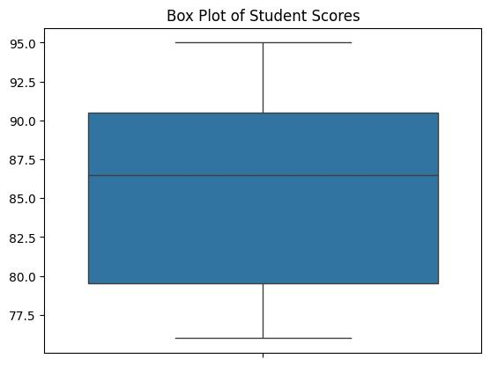
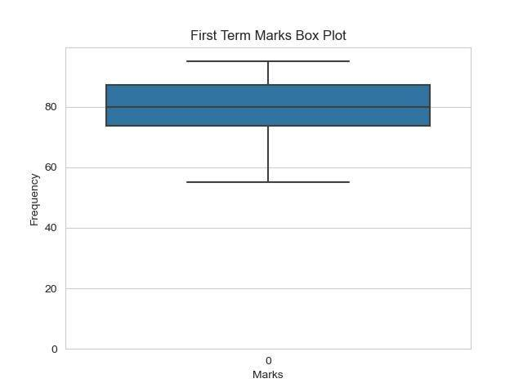
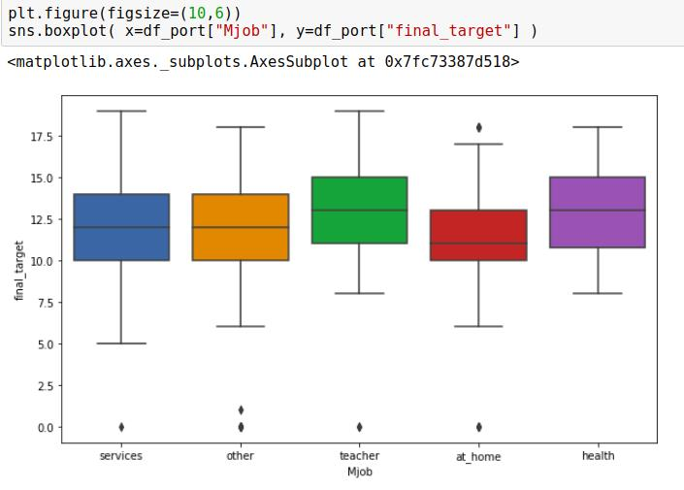
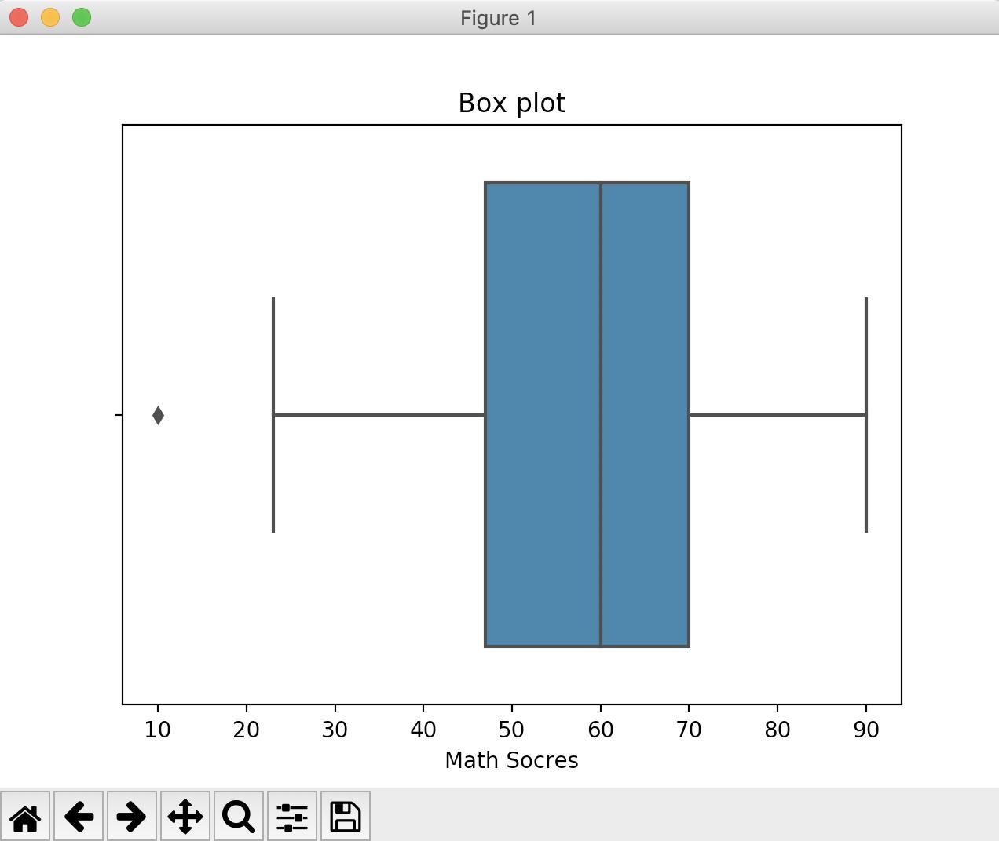
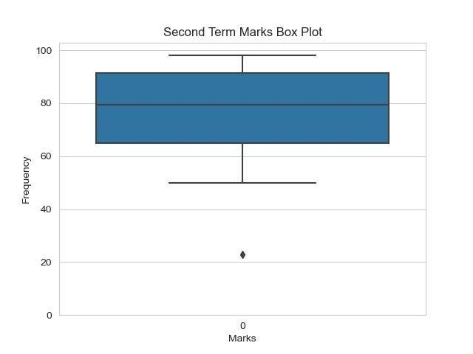
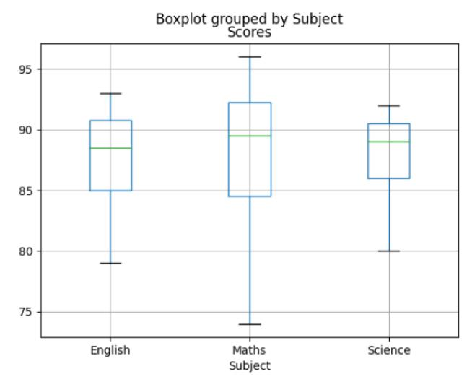

Task 2 – Count Plot for Pass and Fail Students
Introduction
In this task, student marks were analyzed to identify pass and fail students. NumPy was used to create arrays, Pandas was used to create a table, and Seaborn count plot was used to visually compare the number of passed and failed students.

Program
import numpy as np
import pandas as pd
import seaborn as sns
import matplotlib.pyplot as plt

roll=np.array([1,2,3,4,5,6,7,8,9,10,11,12])

marks=np.array([85,35,67,25,90,95,56,78,82,10,98,100])

status=np.where(marks>=40,"Pass","Fail")

print("OUTPUT")

df=pd.DataFrame({
"Roll No":roll,
"Marks":marks,
"Result":status
})

print(df)

sns.boxplot(y=df["Marks"])

plt.title("Student Marks Box Plot")

plt.show()

sns.countplot(x=df["Result"])

plt.title("Student pass fail using count plot")

plt.show()

Output Description
- A table containing roll number, marks, and result status was displayed
- The count plot visually represented the number of pass and fail students
- Comparison between categories became easier through visualization
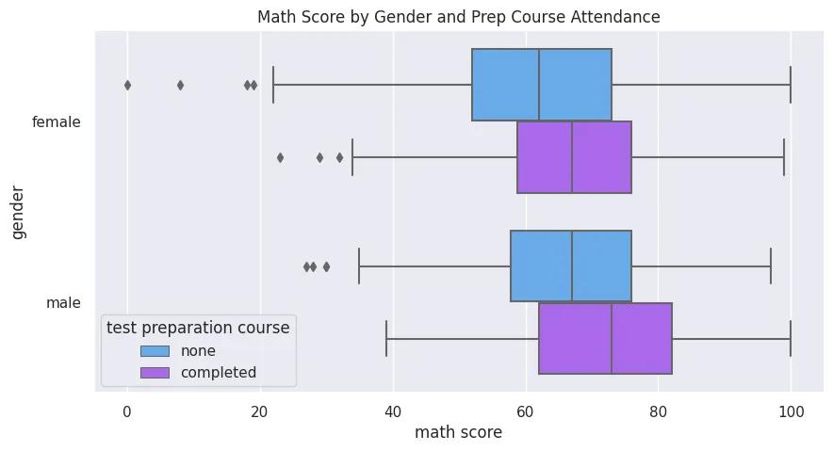
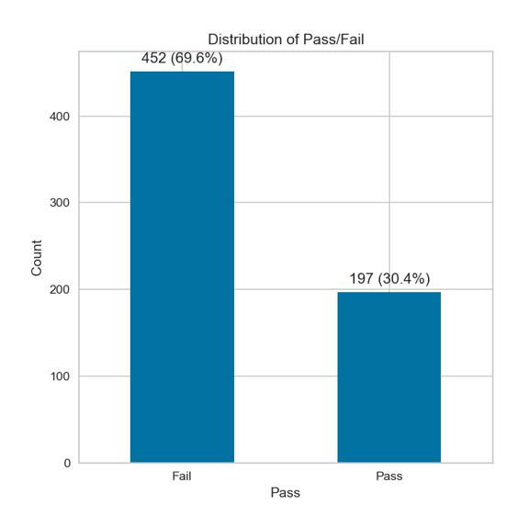
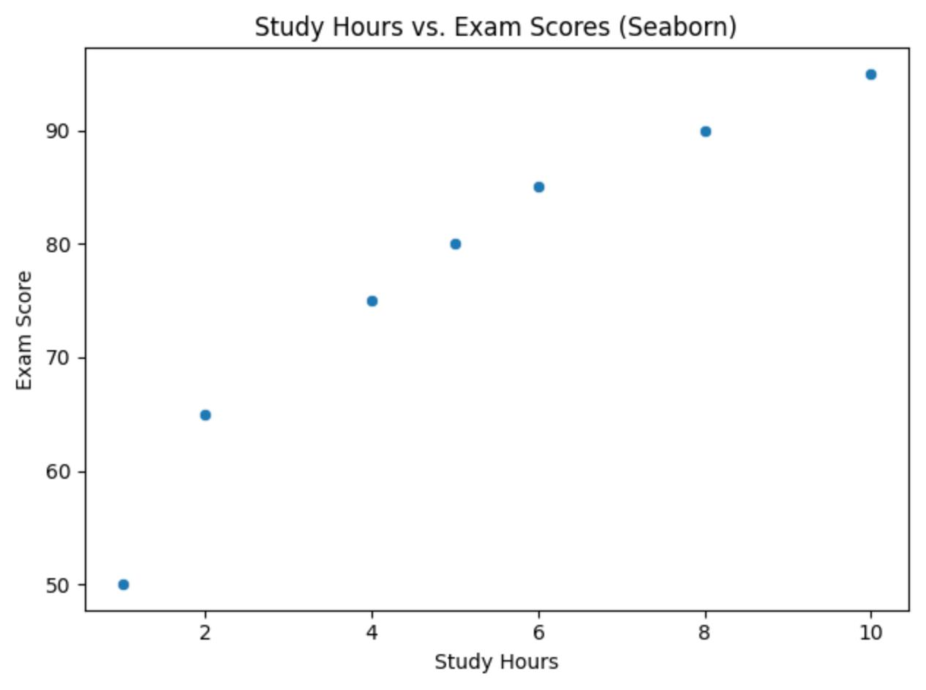
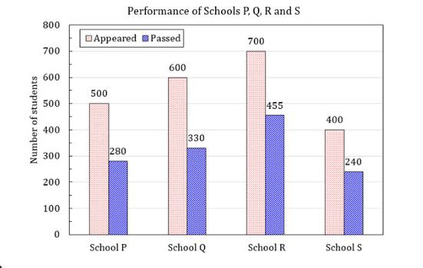
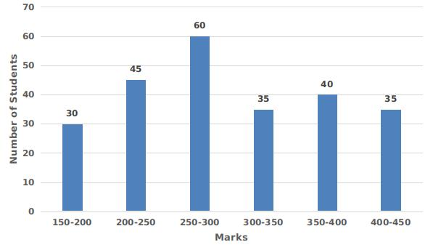

Comparison Graphs in Seaborn
Comparison graphs are used to compare values, categories, or relationships between data.
Graph | Function | Purpose
Line Graph | sns.lineplot() | Compares values over time or sequence
Bar Graph | sns.barplot() | Compares values between categories
Scatter Plot | sns.scatterplot() | Compares relationship between two variables
Box Plot | sns.boxplot() | Compares data distribution
Violin Plot | sns.violinplot() | Compares distribution and density
Count Plot | sns.countplot() | Compares count of categories
Point Plot | sns.pointplot() | Compares category values using points
Swarm Plot | sns.swarmplot() | Compares individual data points
Strip Plot | sns.stripplot() | Compares categorical scatter data

Task 3 – Scatter Plot and Line Plot using Seaborn
Introduction
In this task, student marks and result status were analyzed using scatter plot and line plot. NumPy was used to create arrays, Pandas was used to organize the data into a table, and Seaborn was used to visualize the comparison between pass and fail students.

1. Scatter Plot
Program
import numpy as np
import pandas as pd
import seaborn as sns
import matplotlib.pyplot as plt

marks=np.array([85,35,67,25,90])

result=np.where(marks>=40,"Pass","Fail")

df=pd.DataFrame({
"Marks":marks,
"Result":result
})

sns.scatterplot(x=df["Result"], y=df["Marks"])

plt.title("Pass and Fail Scatter Plot")

plt.show()
Output Description
- A scatter plot was generated successfully
- Relationship between result status and marks was visualized clearly

2. Line Graph
A line graph is used to represent and compare data values using connected lines. It helps visualize changes and trends between categories.
Program
import numpy as np
import pandas as pd
import seaborn as sns
import matplotlib.pyplot as plt

marks=np.array([85,35,67,25,90])

result=np.where(marks>=40,"Pass","Fail")

df=pd.DataFrame({
"Marks":marks,
"Result":result
})

sns.lineplot(x=df["Result"], y=df["Marks"])

plt.title("Pass and Fail Line Graph")

plt.show()
Output Description
- A line graph was generated successfully
- Student marks were compared based on pass and fail status
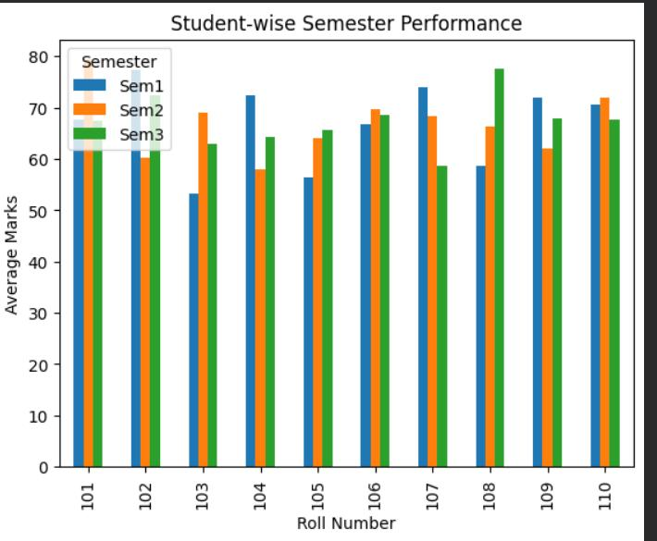

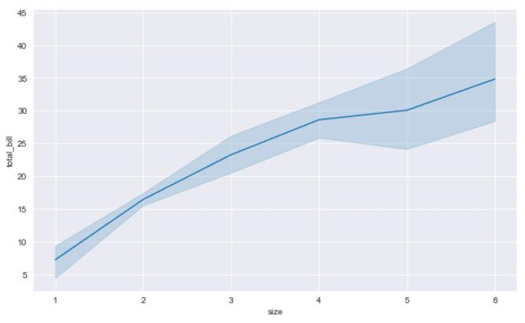
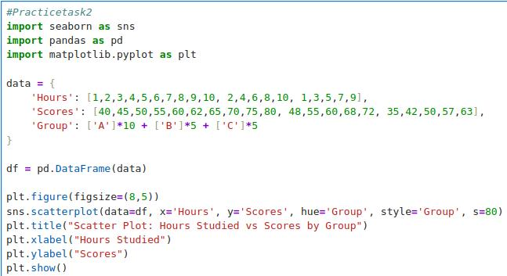
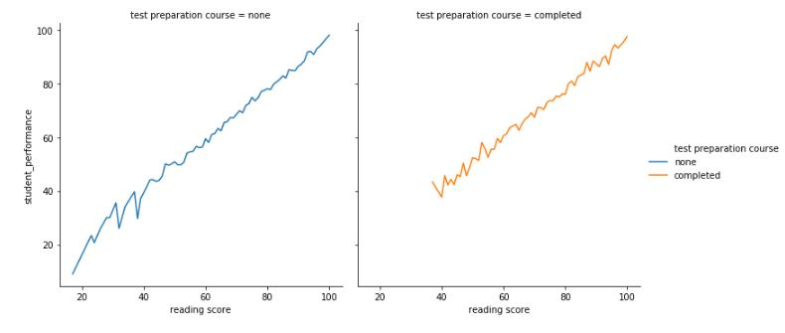

Task 4 – Graph Creation for Sample Student Data using Seaborn
Introduction
Seaborn is used to create attractive statistical graphs easily. In this task, an Excel student dataset was read using Pandas and different types of graphs were created using Seaborn to analyze student marks, attendance, and result status visually.

Program
import pandas as pd
import seaborn as sns
import matplotlib.pyplot as plt

# Reading Excel Dataset
df = pd.read_excel("/content/sampleStudentDataset.xlsx")

# Display Dataset
print(df)

# 1. Line Graph
sns.lineplot(x=df["Name"], y=df["Marks"])

plt.title("Student Marks Line Graph")
plt.xlabel("Student Name")
plt.ylabel("Marks")
plt.xticks(rotation=45)

plt.show()

# 2. Bar Graph
sns.barplot(x=df["Name"], y=df["Marks"])

plt.title("Student Marks Bar Graph")
plt.xlabel("Student Name")
plt.ylabel("Marks")
plt.xticks(rotation=45)

plt.show()

# 3. Scatter Plot
sns.scatterplot(x=df["Attendance"], y=df["Marks"])

plt.title("Attendance vs Marks Scatter Plot")
plt.xlabel("Attendance")
plt.ylabel("Marks")

plt.show()

# 4. Box Plot
sns.boxplot(y=df["Marks"])

plt.title("Student Marks Box Plot")

plt.show()

# 5. Count Plot
sns.countplot(x=df["Result"])

plt.title("Pass and Fail Count Plot")
plt.xlabel("Result")
plt.ylabel("Count")

plt.show()

Output Description
- A line graph was generated to compare student marks
- A bar graph was created to visualize student performance
- A scatter plot compared attendance and marks
- A box plot visualized marks distribution
- A count plot compared pass and fail student count
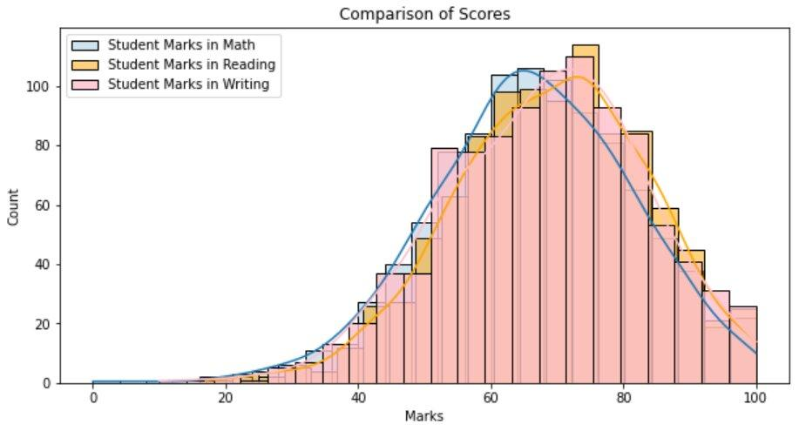
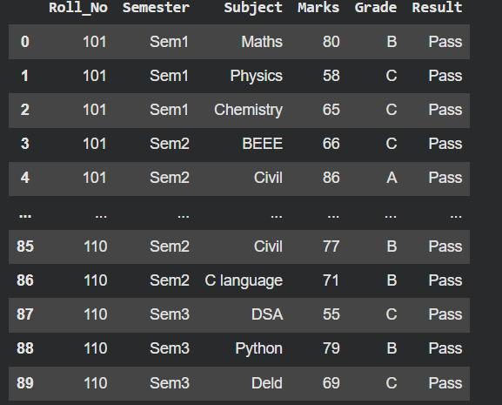
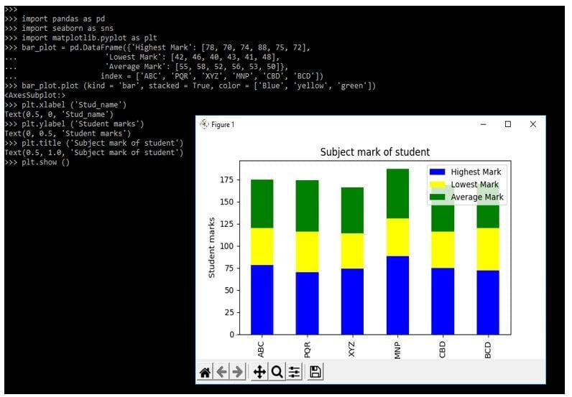

Technologies Used
- Python
- NumPy
- Pandas
- Seaborn
- Matplotlib
- Google Colab

Learning Outcome
On Day 15, I learned how to analyze student performance data using NumPy, Pandas, and Seaborn.
I understood:
- how to create datasets using NumPy arrays
- how to organize data using Pandas DataFrame
- how to generate pass/fail status using conditions
- how to visualize student performance using Seaborn graphs
- how comparison graphs help analyze categorical and numerical data

Conclusion
The Day 15 internship session helped me understand practical student performance analysis and visualization techniques using NumPy, Pandas, and Seaborn.
Different graphs such as box plots, count plots, scatter plots, line graphs, and bar graphs were created successfully to visualize marks, attendance, and result status. This session improved my understanding of statistical visualization and data analysis using Python.

